Financial Forecasting
Cognizant Deepskilling Assessment
By SOBIKA E
21/6/2026
Understand Recursive Algorithms:
Recursion is when a function calls itself to solve a problem. Instead of looping or repeating instructions, the function breaks down a big problem into smaller, similar sub-problems until it reaches a base case (a point where it can stop).
Recursion is helpful because it can make complex problems easier to understand and write. Instead of managing lots of loops and variables, you can solve a problem by focusing on:
Base Case – The simplest version of the problem.
Recursive Case – Reducing the problem step-by-step until it reaches the base case.
Example:
Think of forecasting the future value of an investment. To find the value after n years, you can think:
The value after n years = the value after n-1 years × (1 + rate)
The value after 0 years = starting amount (base case)
With recursion, you can directly describe this relationship instead of using long loops.

We want to calculate the future value of an investment using a recursive approach.
Future value depends on:
The current value
The growth rate
The number of years
Future Value = Current Value × (1 + Growth Rate) ^ Number of Years
We can implement this recursively:
Base Case: If years == 0, the future value is just the current value.
Recursive Case: futureValue(value, rate, years) = futureValue(value, rate, years-1) * (1 + rate)

Now I’ll attach my code and snapshots,
Main.java:
package com.example.financial;

public class Main {
public static double futureValue(double currentValue, double rate, int years) {
if (years == 0) {
return currentValue;
}
return futureValue(currentValue, rate, years - 1) * (1 + rate);
}
public static void main(String[] args) {
double currentValue = 1000.0;
double rate = 0.05;
int years = 10;
double result = futureValue(currentValue, rate, years);
System.out.println("Future Value after " + years + " years: " + result);
System.out.println("\nTime Complexity: O(n) where n = number of years.");
System.out.println("Optimization: You can use memoization or an iterative approach if years is very large.");
}
}

Output:

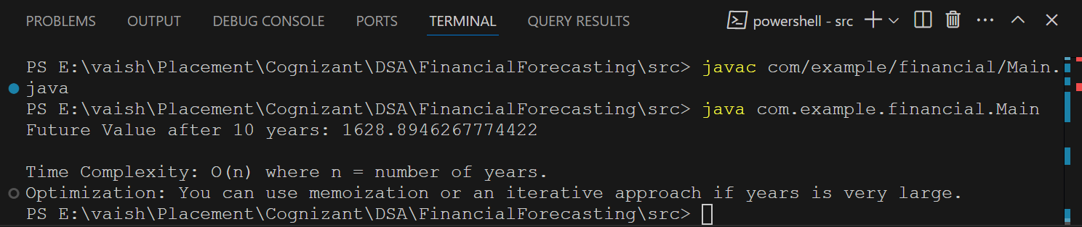
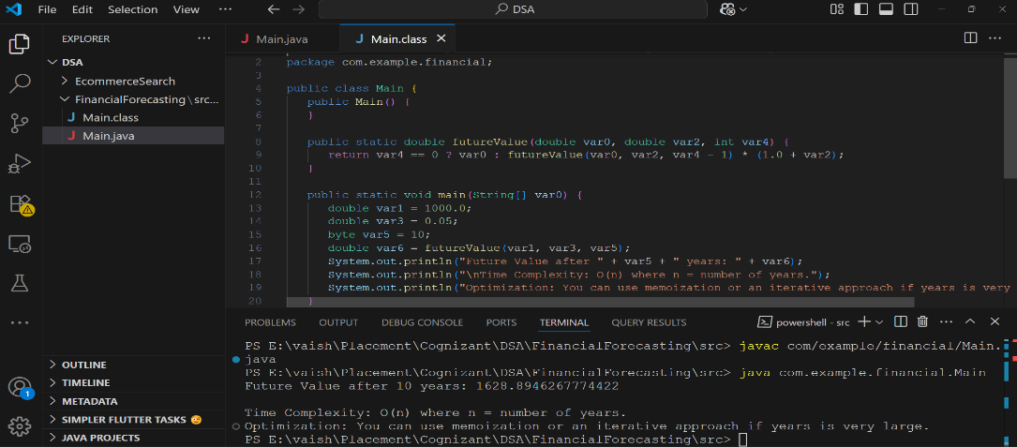

From my analysis,
Algorithm | Time Complexity
Recursive Method | O(n)
How to Optimize the Recursive Solution to Avoid Excessive Computation?
Recursion is elegant, but for very large inputs (e.g., many years), it can become inefficient or cause a stack overflow. Here are ways to optimize it:
Use an Iterative Loop:
Instead of calling the method repeatedly, use a simple for or while loop. This removes the overhead of recursive calls and is ideal for long-term forecasting.
Apply Memoization:
If the calculation involves repeating the same results (in more complex scenarios), cache the results. This saves time by not repeating expensive calculations.
Use the Closed-Form Equation:
For this specific problem (futureValue = currentValue * (1 + rate)^years), skip recursion and compute the result in one step using Math.pow(). This gives an instant result with O(1) time.

